**USING DICTIONARIES**

**Using Dictionaries**

Now that we know how to create a dictionary, we can start using already created dictionaries to solve problems.

In this lesson, you’ll learn how to:

* Use a key to get a value from a dictionary
* Check for existence of keys
* Iterate through keys and values in dictionaries

**Get A Key**

Once you have a dictionary, you can access the values in it by providing the key. For example, let’s imagine we have a dictionary that maps buildings to their heights, in meters:

building_heights = {"Burj Khalifa": 828, "Shanghai Tower": 632, "Abraj Al Bait": 601, "Ping An": 599, "Lotte World Tower": 554.5, "One World Trade": 541.3}

Then we can access the data in it like this:

>>> building_heights["Burj Khalifa"]  
828  
>>> building_heights["Ping An"]  
599

**Instructions**

**1.**

We have provided a dictionary that maps the elements of astrology to the zodiac signs. Print out the list of zodiac signs associated with the "earth" element.

Checkpoint 2 Passed

**2.**

Print out the list of the "fire" signs.

**script.py**

zodiac_elements = {"water": ["Cancer", "Scorpio", "Pisces"], "fire": ["Aries", "Leo", "Sagittarius"], "earth": ["Taurus", "Virgo", "Capricorn"], "air":["Gemini", "Libra", "Aquarius"]}

print(zodiac_elements["earth"])

print(zodiac_elements["fire"])

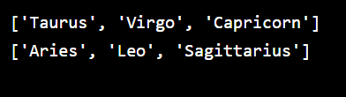

**Get an Invalid Key**

Let’s say we have our dictionary of building heights from the last exercise:

building_heights = {"Burj Khalifa": 828, "Shanghai Tower": 632, "Abraj Al Bait": 601, "Ping An": 599, "Lotte World Tower": 554.5, "One World Trade": 541.3}

What if we wanted to know the height of the Landmark 81 in Ho Chi Minh City? We could try:

print(building_heights["Landmark 81"])

But "Landmark 81" does not exist as a key in the building_heights dictionary! So this will throw a KeyError:

KeyError: 'Landmark 81'

One way to avoid this error is to first check if the key exists in the dictionary:

key_to_check = "Landmark 81"  
  
if key_to_check in building_heights:  
  print(building_heights["Landmark 81"])

This will not throw an error, because key_to_check in building_heights will return False, and so we never try to access the key.

**Instructions**

**1.**

Review the code in the editor and predict what the output will be. Run the code to see if you are correct!

Checkpoint 2 Passed

**2.**

Because "energy" is not a key in zodiac_elements, a KeyError is thrown in the terminal!

Using an if statement, check if "energy" is a key in zodiac_elements. Nest the existing print() statement within the if statement so that it will only execute if "energy" is a key.

Run your code again. This time, there should be no errors in the terminal!

Checkpoint 3 Passed

**3.**

Add the key "energy" to the zodiac_elements. It should map to a value of "Not a Zodiac element". Run the code. Since "energy" is now a key, its value prints to the terminal!

**script.py**

zodiac_elements = {"water": ["Cancer", "Scorpio", "Pisces"], "fire": ["Aries", "Leo", "Sagittarius"], "earth": ["Taurus", "Virgo", "Capricorn"], "air":["Gemini", "Libra", "Aquarius"]}

zodiac_elements["energy"] = "Not a Zodiac element"

if "energy" in zodiac_elements:

  print(zodiac_elements["energy"])

print(zodiac_elements)

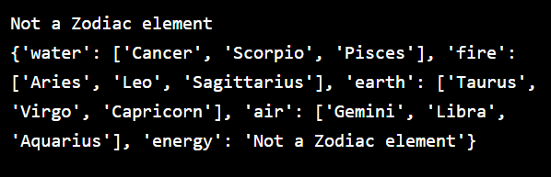

**Try/Except to Get a Key**

We saw that we can avoid KeyErrors by checking if a key is in a dictionary first. Another method we could use is a try/except:

key_to_check = "Landmark 81"  
try:  
  print(building_heights[key_to_check])  
except KeyError:  
  print("That key doesn't exist!")

When we try to access a key that doesn’t exist, the program will go into the except block and print "That key doesn't exist!".

**Instructions**

**1.**

Use a try block to try to print the caffeine level of "matcha". If there is a KeyError, print "Unknown Caffeine Level".

Checkpoint 2 Passed

**2.**

Above the try block, add "matcha" to the dictionary with a value of 30.

**script.py**

caffeine_level = {"espresso": 64, "chai": 40, "decaf": 0, "drip": 120}

caffeine_level["matcha"] = 30

try:

  print(caffeine_level["matcha"])

except KeyError:

  print("Unknown Caffeine Level")

